Automated Passport Photo Taking with Computer Vision

A03 - Home Assignment

Aaron Scifo

Task 1 – Prepare the scenario

3A) Geometrical Transformations

3A.1. Image Cropping
Image cropping involves the selection of a sub-section of an image, this geometrical transformation involves the coordinates which indicate the section within an image that needs to be extracted. This technique is useful as it allows us to take points of interest within an image (ex: top right corner or center of an image) and extract them in various aspect ratios while also removing unneeded parts of a particular image which facilitates computations that might need to be performed on the image at hand.

3A.2. Image Scaling
Image scaling is a geometrical transformation which allows the enlargement of an image or subsections within an image. This technique is highly useful as it allows us to visually see parts of an image that might have been otherwise unsaleable due to their small size. The scaling can be used to resize the image to any given resolution and thus it was chosen as with it we can scale to the required 3:4 resolution

3B) Choice Of Transformation

The Image Cropping geometrical transformation was chosen to extract a 3:4 image. The implementation (found within this project, entitled “task1.py”) draws a 3:4 rectangle superimposed onto the live feed from a webcam. Once the user presses the “s” button the image is cropped with the same dimensions and coordinates as the superimposed rectangle and saved within a file which can be found with this project at “images/task1.png” (after the python script is successfully executed).

Task 2 – Research face detection and facial landmarks.

Haar cascades

Brief
Haar cascades is a machine learning technique which utilizes a set of haar features in order to detect facial landmarks. Haar features can be defined as different shapes composed of different shades of black and white used to identify different parts of a human face. These haar features are used to calculate the deviation from dark pixels to white pixels , this data is used as a feature-set representing an image , the machine model is trained by a collection of postie and negative images (image containing or lacking a human face).The resulting model will be capable of detecting different parts of a human face like the eyes , the mouth and the nose.
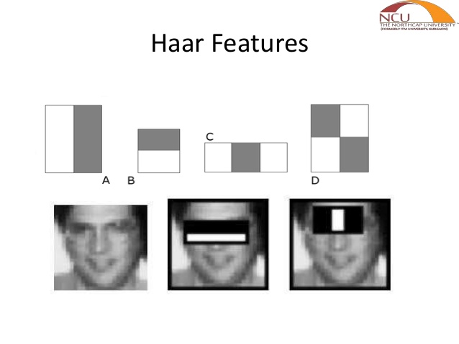

Advantage

Disadvantage
(“OpenCV: Cascade Classifier,” n.d.)⁠

Histogram of Oriented Gradients.

Brief
The HOG algorithm is used in Computer Vision to detect humans , and object detection. HOG works by the calculation and computation of a gradient value of each pixel in an image (a gradient kernel is applied). The resulting gradients are grouped into vectors which are afterwards projected into a histogram (these are called hog features, which represents change in gradient and magnitude in a given image). The generated histogram is plotted onto the original image to find the most relevant features (objects, people), due to the nature of this operation irrelevant background details will be naturally omitted (due to very little change in magnitude and gradient). The extracted hog features and be feed into a machine learning algorithm to predict the desired objects.

Advantage
- HOG is faster than Haar Cascade Algorithm.
- HOG is capable of detecting a person irrespective of their pose (not limited to face detection and face landmark extraction).

Disadvantage
- Not highly efficient when it comes to detect facial landmarks.

Convolutional Neural Networks using dlib.

Brief
Convolutional Neural Networks are machine learning technique that is mainly used (although not limited to) computer vision. Neural Networks imitate the human mind when it comes to learning. Conventional neural networks involve a set of layers called Conventional Layers that apply various filters to the data being processed by the neural network , these conventional layers will be able to extract precious information on the data being processed such as edge detection and shape detection. A well trained Convolutional Neural Network is capable of recognizing various objects and facial landmarks.

Advantage
Highly efficient
state of the art face recogonization

Disadvantage
Hard to train

Chosen Algorithm

